INDEX

UIvs.UXDesign…………………………………2

Abstract: 4

Tools Used: 5

UI/UX Research 7

Low-Fidelity Design Using Penpot 10

High-Fidelity Design Using Penpot 12

Figma UI/UX Design 15

Prototype Development 17

Animation Integration 19

Conclusion 21

**Charity Donation Platform**

# UI vs. UX Design:

In the realm of digital design, the terms UI (User Interface) and UX (User Experience) often surface, sometimes used interchangeably, but they represent distinct facets of the design process. This article aims to shed light on their differences, the roles they play, and considerations for those considering a career in either discipline.

UI primarily encompasses the visual components of a digital interface—the buttons, icons, layouts, and other elements that users interact with. Conversely, UX encompasses the entirety of the user's interaction with a product or service, including their emotions and perceptions. While UI focuses on aesthetics and usability, UX delves deeper into the overall user journey and satisfaction.

UX designers are primarily concerned with creating products that are functional, accessible, and enjoyable to use. Their tasks may involve conducting user research, creating user personas, mapping user journeys, and prototyping solutions. On the other hand, UI designers are responsible for crafting the visual elements of digital interfaces, including layouts, colour schemes, and interactive components. They work closely with developers to ensure that designs are translated into functional, visually appealing products.

While UI and UX designers share some skills, such as empathy and collaboration, each role requires its own unique skill set. UX designers often have backgrounds in fields like psychology, design, or computer science, whereas UI designers may specialize in digital design, graphic design, or interaction design. While a formal degree isn't always required, it can open doors to new opportunities in the field.

Deciding between a career in UI or UX design hinges on personal interests, strengths, and career goals. Those drawn to problem-solving, and technology may find UX design appealing, while individuals with a knack for aesthetics and creativity may gravitate towards UI design. Exploring both disciplines through classes, blogs, or industry networking can provide valuable insights for making an informed decision.

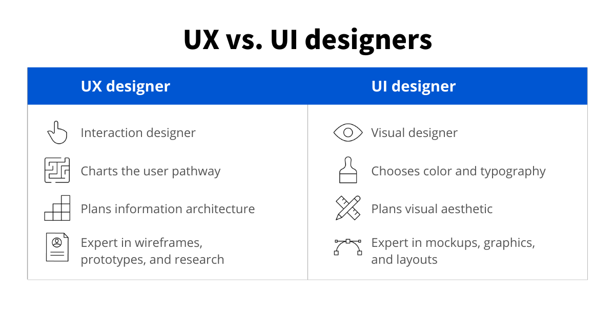

Beyond UI and UX designers, the field of user experience encompasses a range of related roles. UX researchers delve into user behaviours and preferences, while UX writers craft the textual content of digital interfaces. Interaction designers focus on refining user interactions, while developers bring designs to life through coding. Product designers oversee the entire product development process, while content strategists manage marketing content throughout its lifecycle.

In conclusion, UI and UX design are integral components of the digital design landscape, each with its own unique focus and responsibilities. Understanding the nuances between these roles is essential for aspiring designers navigating their career paths in this dynamic field.

# Abstract:

# Abstract:

# In the ever-evolving landscape of e-commerce, providing an unparalleled user experience (UX) is paramount for success. This abstract delves into the core elements of an e-commerce application aimed at enriching user engagement and satisfaction.Firstly, the abstract discusses the importance of intuitive and user-friendly interfaces, emphasizing the need for seamless navigation and accessibility across various devices. Secondly, it explores the significance of personalized recommendations and tailored content, highlighting the role of data analytics and machine learning algorithms in understanding user preferences and behavior.

# Furthermore, the abstract addresses the vital aspect of secure transactions and data protection, emphasizing the implementation of robust security measures to instill trust and confidence among users. Additionally, it underscores the significance of responsive customer support and efficient resolution mechanisms to foster long-term customer relationships and loyalty. Moreover, the abstract explores the integration of social media functionalities and community engagement features to enhance user interaction and foster a sense of belonging within the e-commerce platform. Finally, it touches upon the importance of continuous optimization through A/B testing and user feedback analysis to adapt to evolving user needs and preferences.

# In conclusion, this abstract underscores the holistic approach required to develop and maintain a successful e-commerce application, focusing on elements such as intuitive design, personalized experiences, security, customer support, social integration, and iterative improvement strategies.

# Tools Used:

**Miro**

Miro emerged as our digital whiteboard and collaborative workspace, serving as the cornerstone of our brainstorming sessions, ideation processes, and visualizations. With its intuitive interface and robust features, Miro facilitated dynamic collaboration among team members, regardless of geographical location. From mapping out user flows to wireframing interface layouts, Miro provided us with a flexible canvas to materialize our ideas and concepts in real-time. Its extensive library of templates and plugins further enriched our creative process, enabling us to explore diverse design possibilities and iterate rapidly.

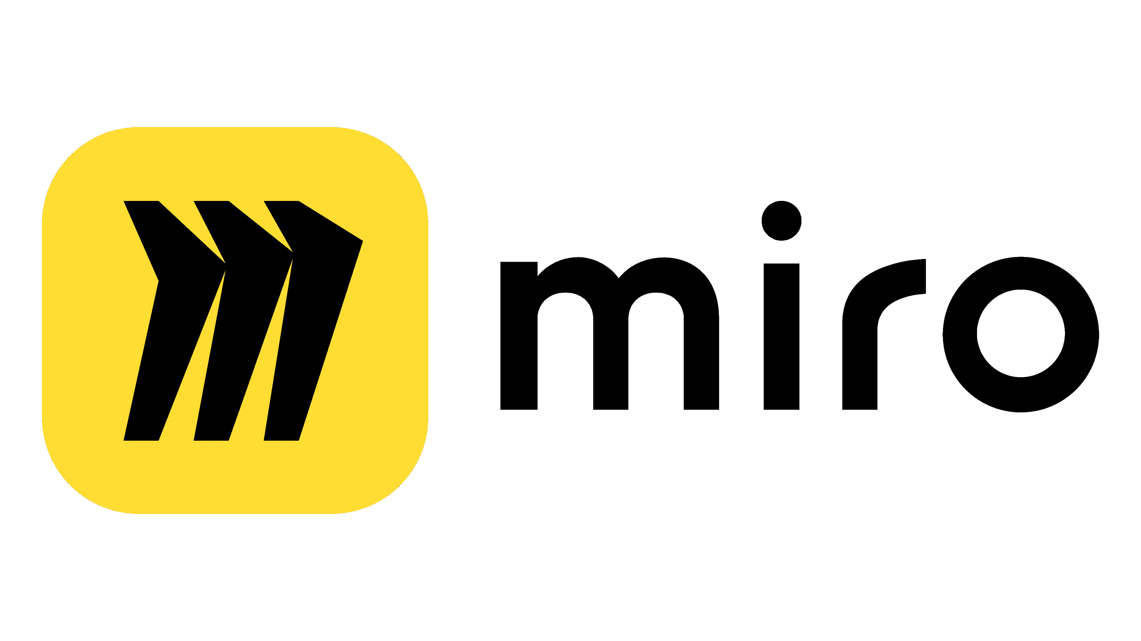

**Penpot**

Penpot emerged as a powerful tool for creating high-fidelity design mock-ups and interactive prototypes, elevating our design process to new heights. As an open-source platform, Penpot offered unparalleled flexibility and customization options, empowering us to tailor our designs to the unique needs of our project. With its intuitive interface and comprehensive feature set, Penpot enabled us to translate conceptual designs into tangible, visually compelling representations with ease. Whether refining interface elements or fine-tuning user interactions, Penpot emerged as a valuable asset in our quest for design excellence.

**Figma**

Figma emerged as the cornerstone of our UI/UX design process, offering a versatile platform for creating, sharing, and iterating on designs collaboratively. Its cloud-based nature facilitated seamless collaboration among team members, allowing for real-time feedback, version control, and efficient design handoff. Figma's robust set of features, including its powerful prototyping capabilities and extensive library of design assets, empowered us to create cohesive and visually stunning designs that resonate with our target audience. Additionally, Figma's integrations with other tools and platforms enhanced our workflow efficiency, enabling smooth transitions between design phases and facilitating seamless collaboration across departments.

In summary, our selection of Miro, Penpot, and Figma as our primary design tools was driven by their collective ability to streamline our design process, foster collaboration, and empower us to deliver a polished, user-centric Charity Donation Platform. By leveraging the capabilities of these industry-standard tools, we were able to translate our vision into reality and create a platform that exceeds expectations in both form and function.

# UI/UX Research

**Problem Statement**

As e-commerce continues to dominate consumer transactions globally, the significance of user interface (UI) and user experience (UX) design in such platforms becomes increasingly crucial. However, amidst the rapid evolution of technology and shifting consumer expectations, numerous challenges persist in optimizing UI/UX for e-commerce applications. This research aims to identify and address these challenges to enhance the usability, engagement, and overall satisfaction of users within e-commerce environments.

**Problem Goal**

The overarching goal of the UI/UX research in the context of e-commerce applications is to optimize the digital shopping experience to better meet the needs and expectations of users, thereby enhancing engagement, satisfaction, and conversion rates. Investigate and implement UI/UX design principles that improve the usability of e-commerce platforms, focusing on intuitive navigation, clear information architecture, and efficient search functionalities to facilitate smoother user interactions.

**Design Thinking**

Employ empathy to understand user needs. Define key challenges in e-commerce UX/UI. Ideate innovative solutions through collaborative brainstorming. Prototype designs for rapid iteration and testing. Iterate based on feedback to enhance usability, personalization, trust, and accessibility. Ultimately, deliver seamless, engaging, and secure e-commerce experiences that drive user satisfaction and conversion.

**Competitive Analysis**

Analyze competitors' e-commerce UI/UX designs, including navigation, product presentation, checkout process, and customer support. Evaluate strengths and weaknesses in usability, personalization, security, and mobile responsiveness. Identify emerging trends and best practices to inform iterative improvements and maintain a competitive edge in the digital marketplace.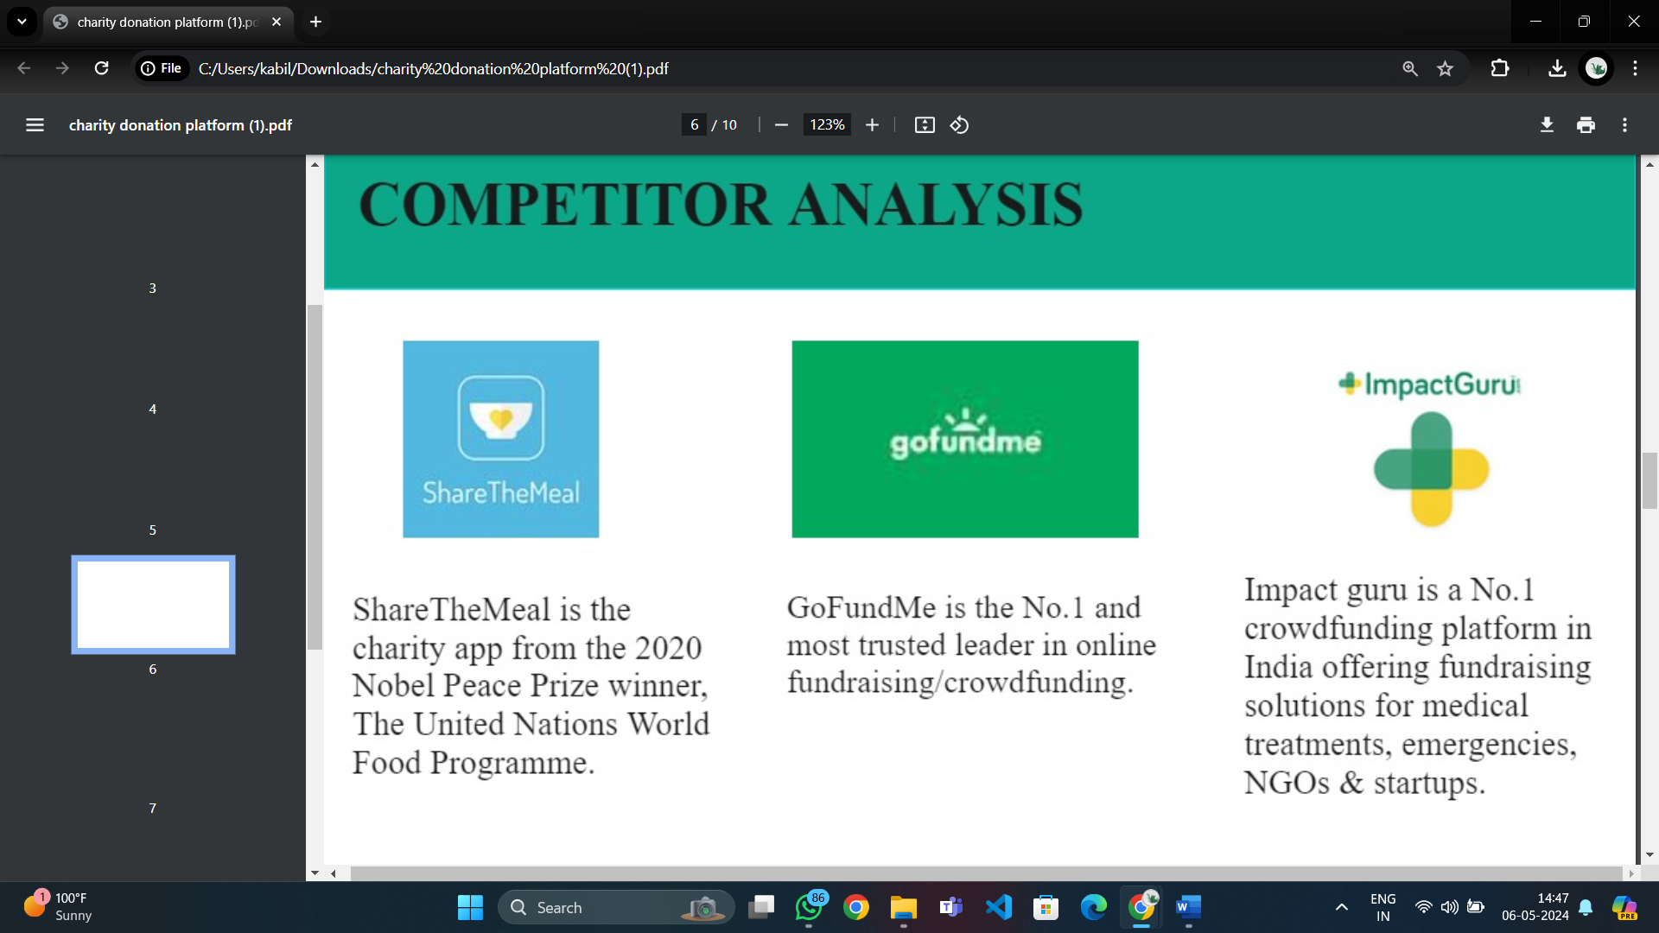

**Qualitative and Quantitative Analysis**

To gain insights into donor preferences and behaviours, we conducted both qualitative and quantitative analyses. Qualitative methods included user interviews and surveys, while quantitative methods involved data analysis of donation trends and user interactions with existing platforms.

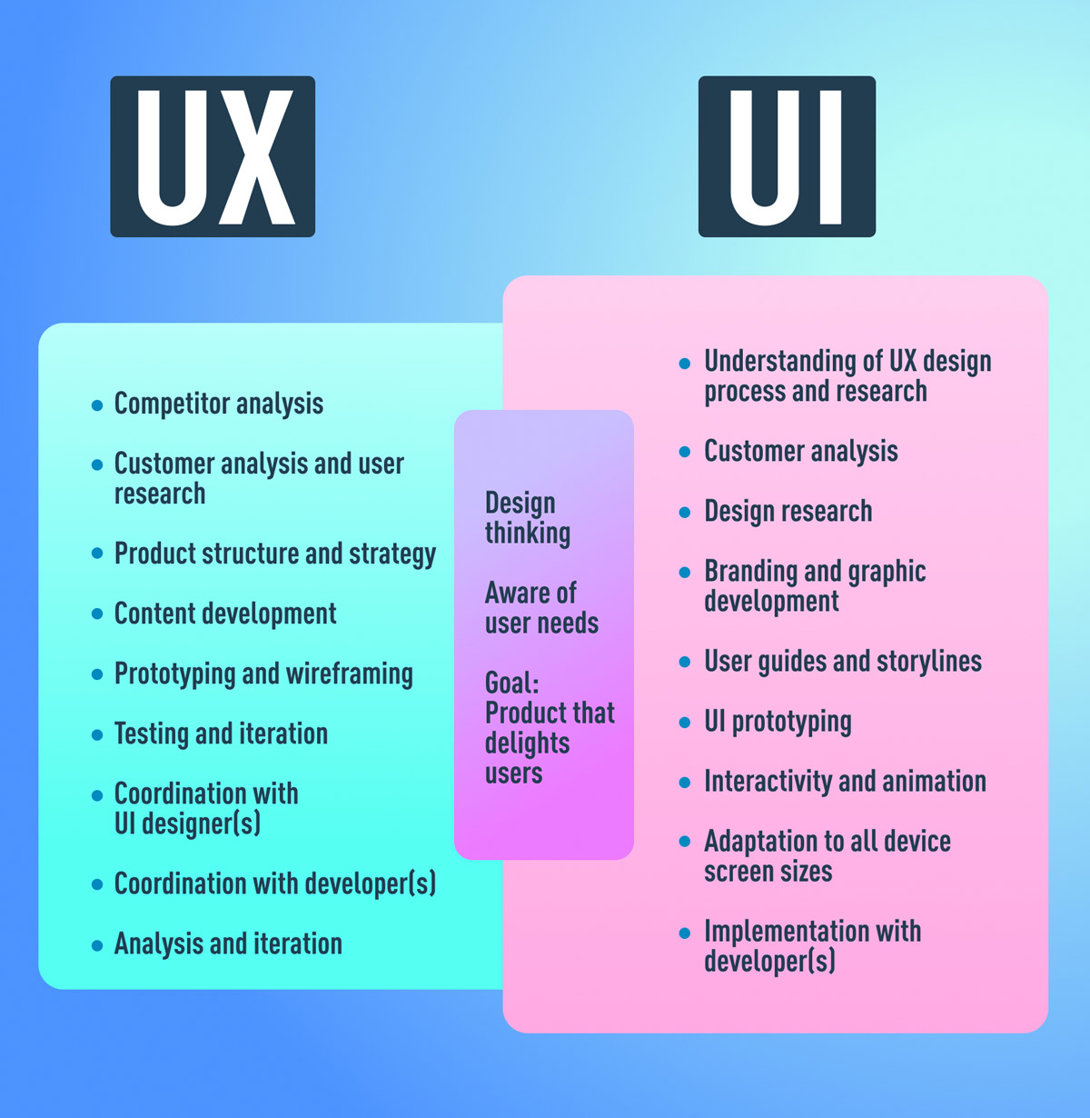

**User Persona**

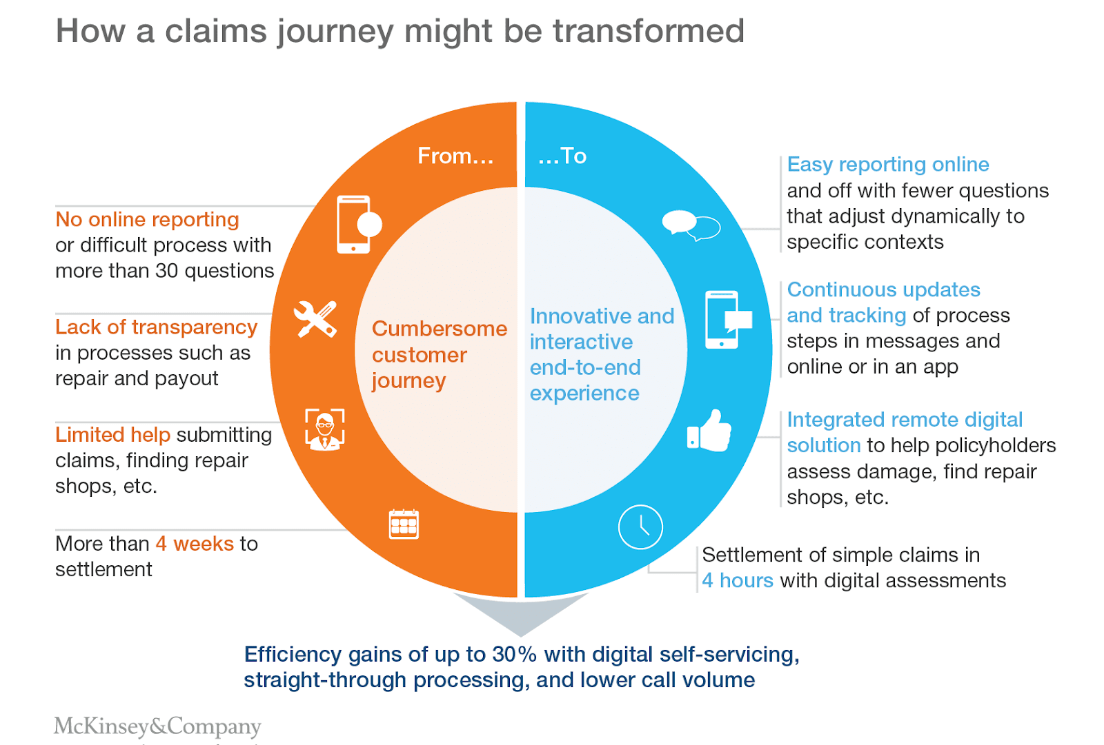Based on our research findings, we developed detailed user personas to represent the diverse needs and motivations of online shoppers. These personas helped us empathize with our target audience and guide our design decisions throughout the project.

**User Flow**

We mapped out the user flow to visualize the journey of online shoppers would take when using our platform. This involved identifying key touchpoints, decision points, and interactions to ensure a seamless and intuitive donation process.

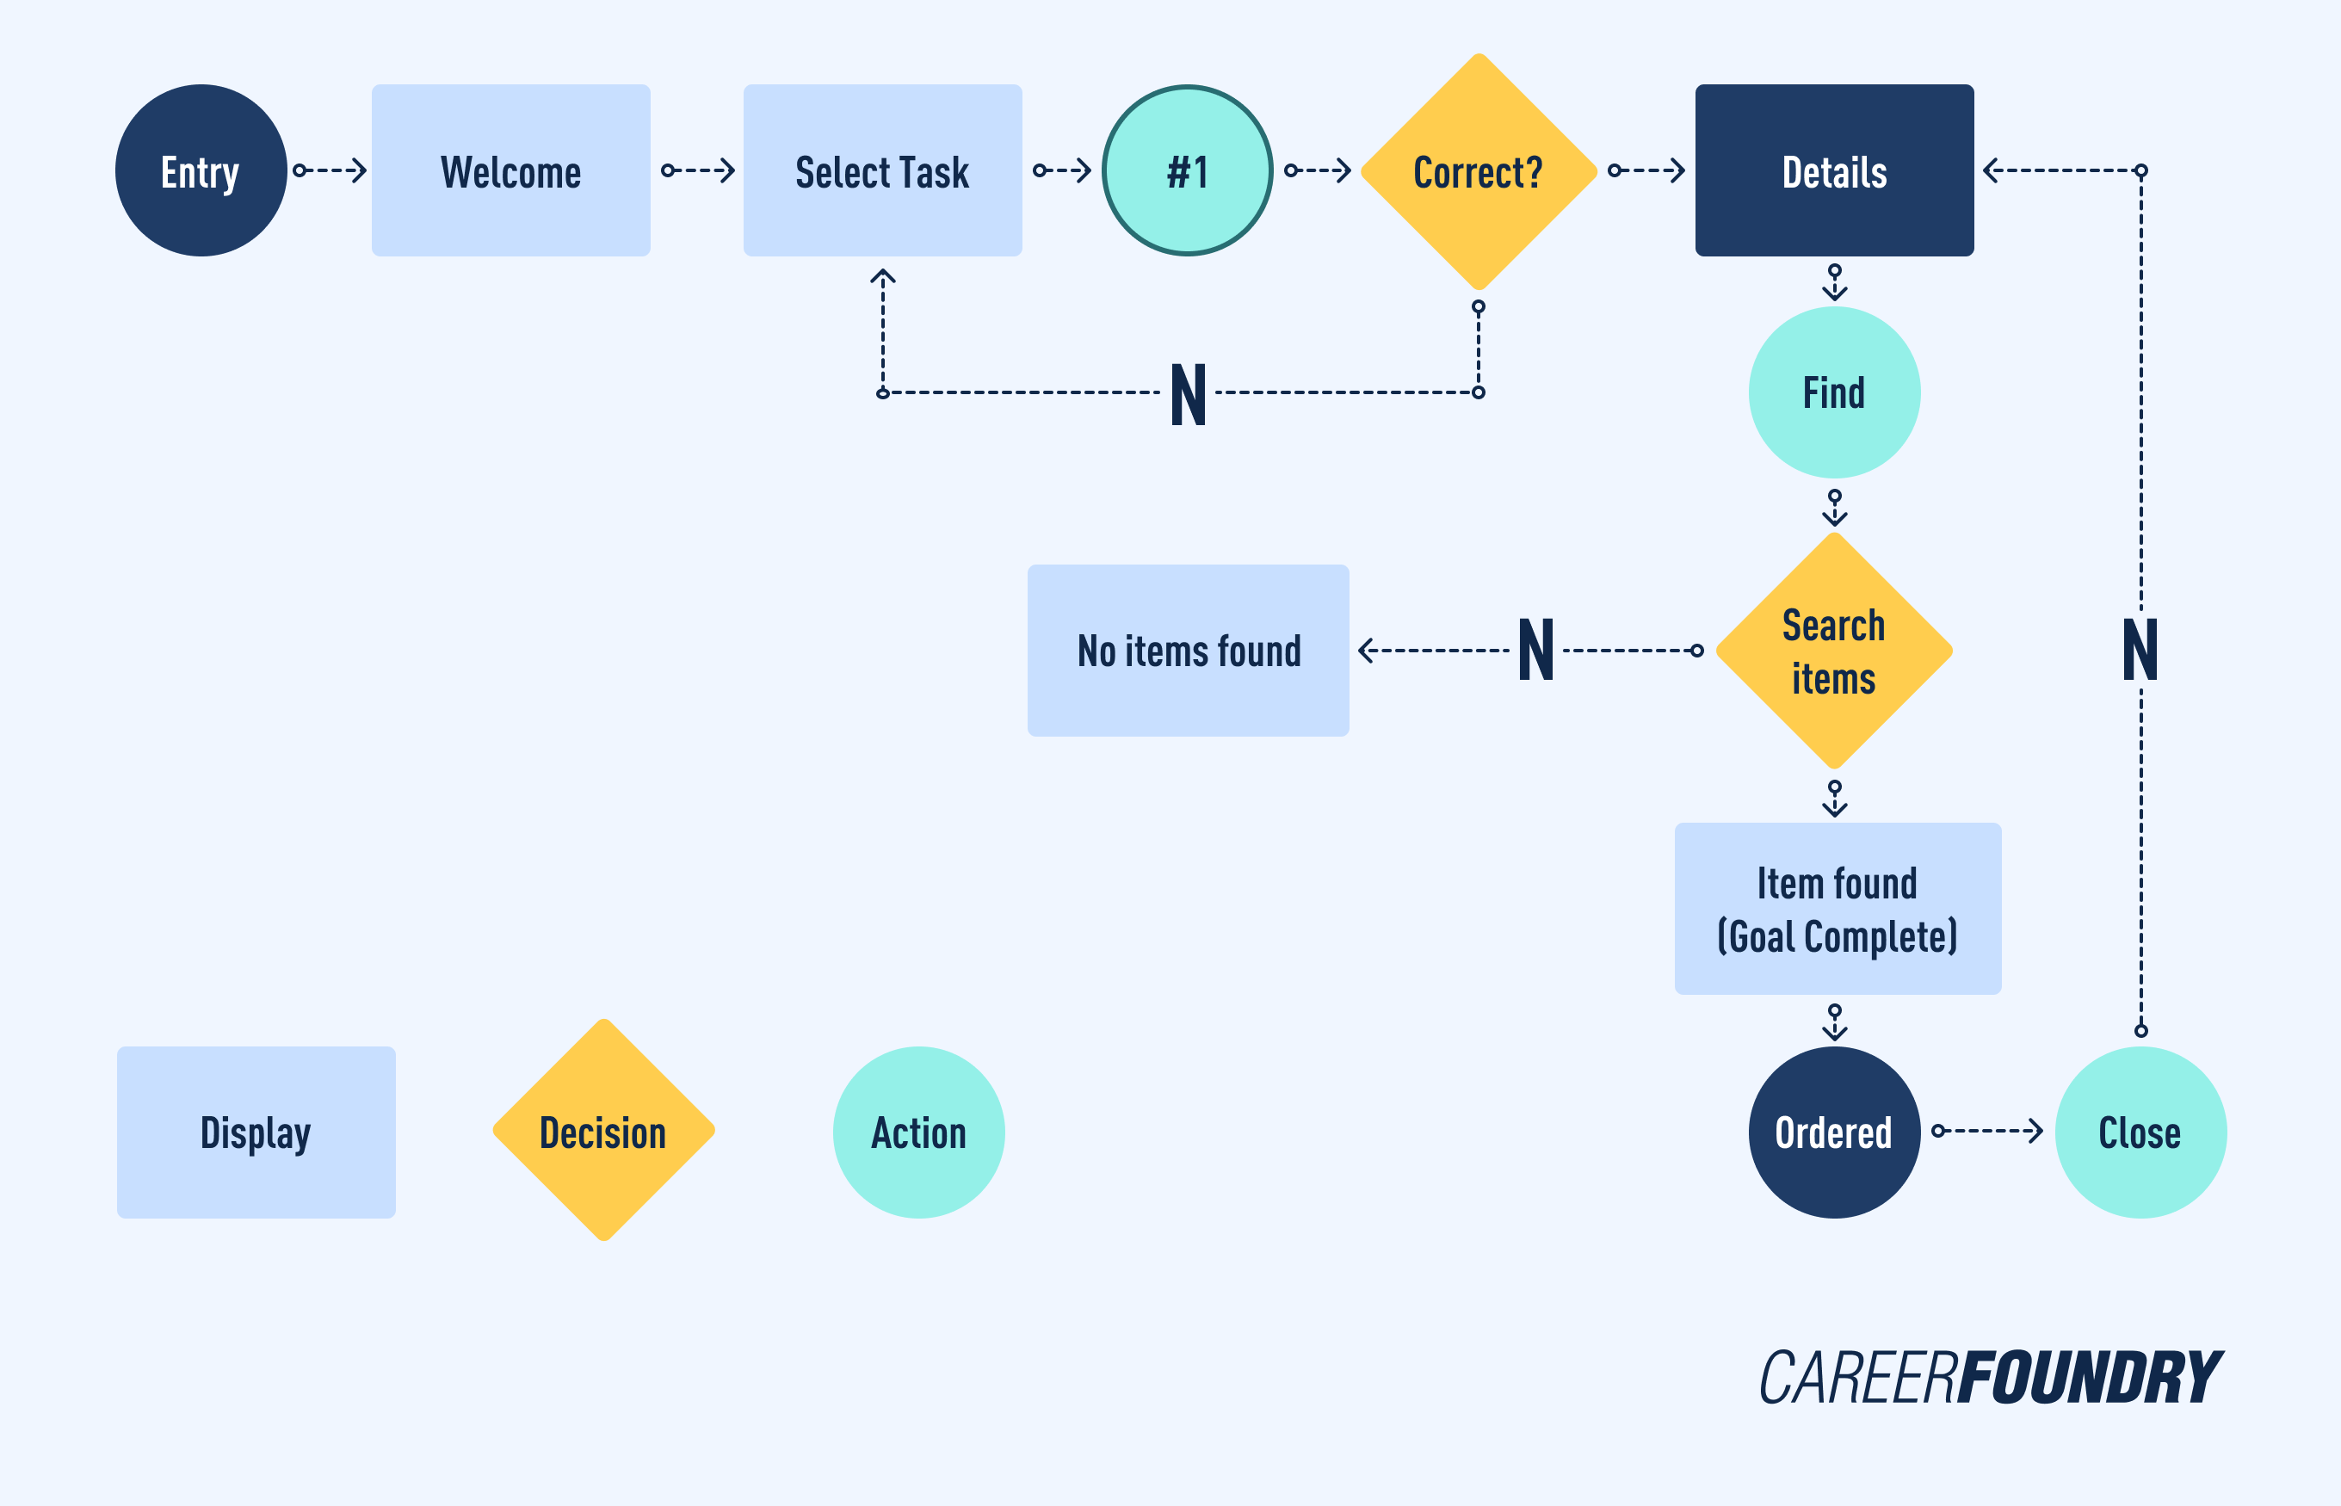

**Raw Sketch**

To explore design concepts and iterate on ideas, we created raw sketches of the platform interface. These sketches served as a starting point for our design iterations, allowing us to quickly explore different layouts, features, and visual styles.

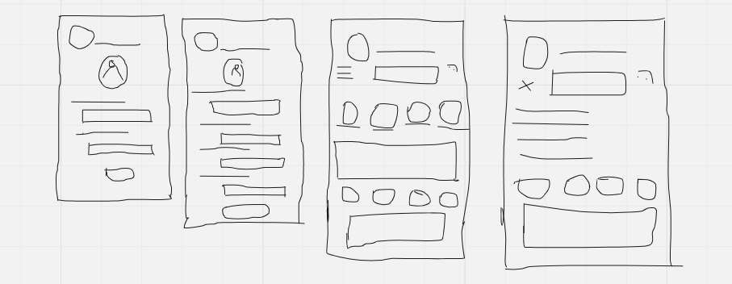

# Low-Fidelity Design Using Penpot

Low-fidelity design using Penpot served as our initial exploration phase, where we focused on conceptualizing ideas and experimenting with different design concepts. The primary goal of this phase was to quickly iterate through various design possibilities without getting bogged down by details. Key features of our low-fidelity design process using Penpot included:

Sketching Concepts:

We started by sketching out rough concepts and wireframes using Penpot's intuitive drawing tools. These sketches helped us visualize layout ideas, content placement, and overall flow without committing to specific design elements.

Iterative Prototyping:

With Penpot's prototyping capabilities, we created simple interactive prototypes to test out navigation flows and user interactions. These prototypes allowed us to gather feedback early in the design process and make informed decisions about the overall user experience.

Collaborative Feedback:

Penpot's collaborative features enabled team members to provide feedback and iterate on designs in real-time. By sharing our low-fidelity designs with stakeholders, we were able to gather valuable insights and refine our concepts iteratively.

# High-Fidelity Design Using Penpot

As we transitioned from the conceptualization phase to refinement, Penpot emerged as our go-to tool for high-fidelity design, enabling us to meticulously flesh out details and polish the visual elements of our Charity Donation Platform. This phase was pivotal in creating pixel-perfect representations of our design concepts, laying the groundwork for implementation. Here's an elaboration on our approach and the key features of our high-fidelity design process using Penpot:

Detailed Mockups:

With Penpot's robust design tools at our disposal, we meticulously crafted detailed mockups that accurately depicted the final look and feel of the Charity Donation Platform. These mockups incorporated precise typography, carefully curated color schemes, and thoughtfully designed visual elements to ensure consistency and coherence across the interface. By paying close attention to every detail, we aimed to create an immersive and visually appealing user experience that resonated with our target audience.

Interactive Prototypes:

Building upon the foundation laid by our low-fidelity prototypes, we enriched our high-fidelity designs with interactive elements and animations using Penpot's prototyping features. These interactive prototypes allowed us to simulate user interactions and demonstrate key features of the platform in a realistic manner. By providing stakeholders with a tangible preview of the final product, we could gather feedback and iterate on our designs with confidence, ensuring that the product met user needs and expectations effectively.

Design System Implementation:

Penpot's support for design systems proved invaluable in establishing a comprehensive library of reusable components, styles, and assets. This design system served as a centralized repository for design elements, ensuring consistency and efficiency throughout the design process. By standardizing design patterns and workflows, we enabled seamless collaboration among team members and facilitated scalability as the project evolved. Additionally, the design system enhanced our ability to maintain design coherence across different sections of the platform, contributing to a cohesive user experience.

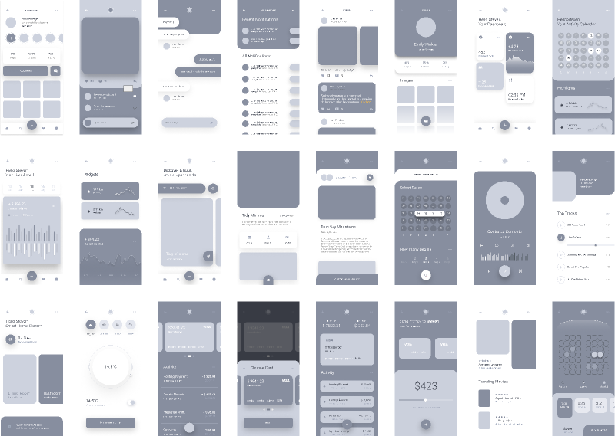

Design Handofff:

With Penpot's design handoff capabilities, we seamlessly bridged the gap between design and development by generating assets and specifications for developers. These handoff documents provided developers with clear guidance on implementing the design elements accurately, reducing the risk of misinterpretation and streamlining the development process. By facilitating effective communication between design and development teams, Penpot's design handoff feature accelerated the implementation phase, ensuring a smooth transition from design to development.

# Figma UI/UX Design

In our quest to create a seamless and engaging user experience for our Charity Donation Platform, we turned to Figma as our primary tool for UI/UX design. Figma's versatility, collaborative features, and robust design capabilities empowered us to translate our vision into reality effectively. Here's an overview of our approach and the key features of our UI/UX design process using Figma:

Figma's intuitive interface and powerful design tools facilitated seamless iteration and exploration of design concepts. We leveraged Figma's flexible layout grids, smart selection tools, and advanced vector editing capabilities to refine our design elements iteratively. By experimenting with different layouts, color schemes, and typography options, we were able to fine-tune our designs and achieve the desired look and feel for the Charity Donation Platform.

One of Figma's standout features is its collaborative design environment, which enabled real-time collaboration among team members regardless of their location. Through Figma's shared design files and live editing capabilities, team members could collaborate on designs simultaneously, share feedback, and iterate on ideas in real-time. This collaborative workflow fostered a dynamic exchange of ideas and ensured that everyone was aligned on the design direction, ultimately leading to better outcomes.

Figma's prototyping features allowed us to bring our designs to life by creating interactive prototypes and simulating user interactions. With Figma's easy-to-use prototyping tools, we could define user flows, link different screens, and incorporate interactive elements such as buttons, menus, and animations. These interactive prototypes provided stakeholders with a tangible preview of the user experience, enabling us to gather feedback early in the design process and make informed decisions about the user interface and interaction design.

Figma's support for component libraries and design systems played a crucial role in maintaining consistency and scalability across our designs. We established a comprehensive library of reusable components, styles, and assets within Figma, ensuring consistency in design elements throughout the Charity Donation Platform. By standardizing design patterns and workflows, we streamlined the design process and facilitated collaboration among team members. Additionally, Figma's design system capabilities enabled us to scale our designs efficiently as the project evolved, ensuring coherence and efficiency across different sections of the platform.

With Figma's design handoff features, we were able to streamline the transition from design to development by generating assets and specifications for developers. Figma's design handoff documents provided developers with clear guidance on implementing design elements accurately, reducing the risk of misinterpretation and accelerating the development process. By facilitating effective communication between design and development teams, Figma's design handoff feature ensured a smooth and efficient implementation phase.

# Prototype Development

In our journey to create a user-centric Charity Donation Platform, prototyping played a pivotal role in bringing our design concepts to life and refining the user experience. Through iterative prototyping, we were able to simulate user interactions, test design assumptions, and gather feedback early in the design process. Here's an overview of our approach and the key elements of our prototype development process:

Prototyping Tools:

We utilized industry-leading prototyping tools such as Figma and Penpot to develop interactive prototypes of the Charity Donation Platform. These tools provided us with intuitive interfaces and robust features for creating dynamic and realistic prototypes.

Interactive Elements:

Our prototypes featured a range of interactive elements, including buttons, menus, dropdowns, sliders, and form fields. These interactive elements allowed users to navigate through the platform, explore features, and interact with various functionalities, providing a hands-on experience of the proposed user interface.

User Flows:

We mapped out comprehensive user flows within our prototypes to simulate the journey that users would take when interacting with the Charity Donation Platform. By defining user flows, we could identify potential pain points, optimize navigation paths, and ensure a smooth and intuitive user experience.

Visual Design:

Our prototypes incorporated visual design elements such as typography, colour schemes, icons, and imagery to convey the brand identity and create a visually appealing interface. We paid close attention to visual hierarchy, layout consistency, and aesthetic coherence to enhance the overall user experience.

Presentation and Documentation:

We documented our prototype development process, including design decisions, rationale, and feedback received, to provide context and transparency to stakeholders. We also presented our prototypes to stakeholders and decision-makers, showcasing the envisioned user experience and gathering final approvals before proceeding to the implementation phase.

# Animation Integration

Animation played a vital role in enhancing the user experience of our Charity Donation Platform, adding dynamism, delight, and clarity to the interface. Through thoughtful animation integration, we aimed to engage users, communicate feedback, and guide them through various interactions seamlessly. Here's an overview of our approach and the key elements of animation integration in our platform:

Purposeful Animation:

Every animation within our platform served a specific purpose, whether it was to provide visual feedback, indicate progress, or guide users' attention. By ensuring that animations had a clear and meaningful function, we minimized distraction and enhanced usability, contributing to a more intuitive and enjoyable user experience.

Feedback and Response:

Animation was used to provide immediate feedback to users, reinforcing their actions and guiding them through the interface. For example, button animations signalled a successful interaction, loading animations indicated progress, and error animations alerted users to potential issues. These feedback animations helped users understand the system's response to their actions, reducing uncertainty and improving user confidence.

Visual Hierarchy:

Animation was employed to establish visual hierarchy and prioritize content within the interface. By animating elements such as transitions, entrances, and exits, we directed users' attention to important information and actions, guiding them through the interface flow naturally. This helped users navigate the platform more efficiently and focus on key tasks without feeling overwhelmed by cluttered or distracting elements.

Delight and Engagement:

In addition to serving functional purposes, animation was used to inject moments of delight and surprise into the user experience. Thoughtfully designed animations, such as subtle micro-interactions, playful transitions, and charming loading sequences, enhanced the overall aesthetic appeal of the platform and fostered a sense of delight and engagement among users.

Performance Optimization:

While animation added value to the user experience, we prioritized performance optimization to ensure smooth and responsive interactions across devices and network conditions. By implementing lightweight and performant animation techniques, such as CSS animations and hardware-accelerated transitions, we minimized rendering overhead and maintained high performance, ensuring that animations enhanced rather than detracted from the user experience.

Accessibility Considerations:

In designing animations, we considered accessibility principles to ensure that all users, including those with disabilities, could access and interact with the platform effectively. We provided options to customize or disable animations for users with motion sensitivity or cognitive impairments, ensuring inclusivity and equal access to the platform's features and content.

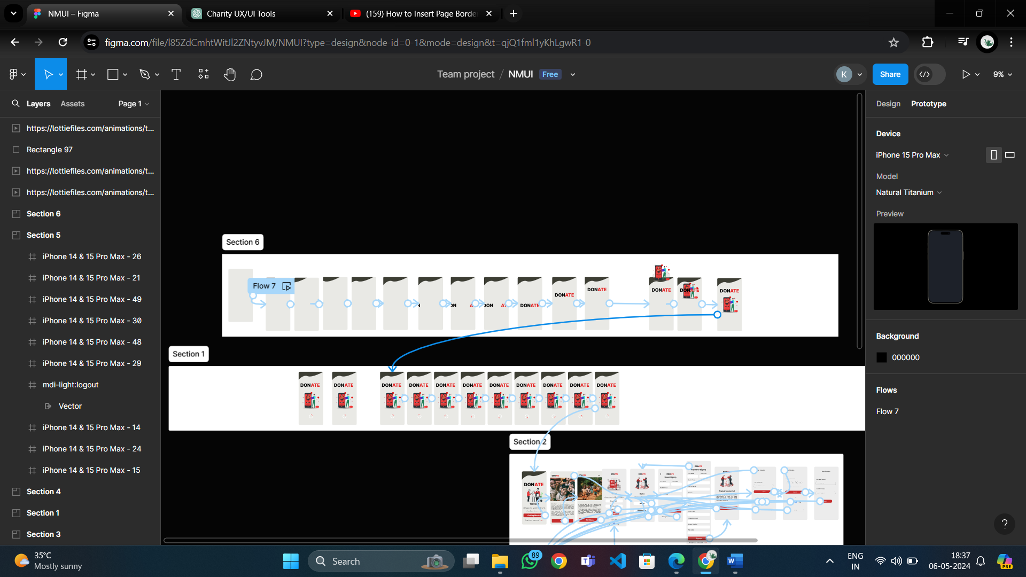

# Conclusion

In our journey to create a Charity Donation Platform, we've prioritized user experience (UX) and user interface (UI) design to ensure a seamless and engaging interaction for our users. Through meticulous research, iterative prototyping, and thoughtful animation integration, we've crafted a platform that not only meets users' functional needs but also delights and engages them. Our commitment to purposeful design, performance optimization, and accessibility ensures that all users can access and enjoy the platform, fostering a sense of community and impact in the realm of philanthropy. As we continue to refine and iterate on our design, we remain dedicated to delivering a user-centric experience that empowers users to make a difference in the world.